Database Management Tool
# Source: AI Source: Provided by: [Data Path: Persons Table -> ID Column: 1, Name_En Column: Motasem Essam] -> From: [ChatGPT] on [6/10/2026]
A Database Management Tool is a software application used to interact with, manage, and manipulate databases easily — often through a graphical interface (GUI) or command line.

✅ What It Helps You Do:
# Source: AI Source: Provided by: [Data Path: Persons Table -> ID Column: 1, Name_En Column: Motasem Essam] -> From: [ChatGPT] on [6/10/2026]
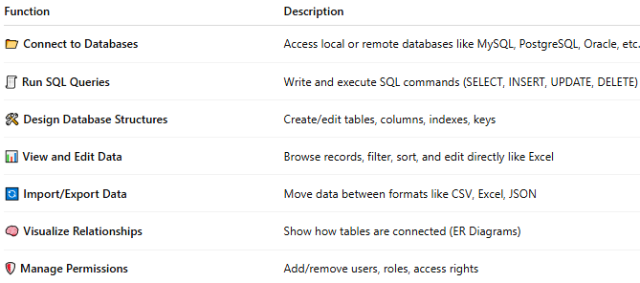
Function | Description
📂 Connect to Databases | Access local or remote databases like MySQL, PostgreSQL, Oracle, etc.
🧾 Run SQL Queries | Write and execute SQL commands (SELECT, INSERT, UPDATE, DELETE)
🛠️ Design Database Structures | Create/edit tables, columns, indexes, keys
📊 View and Edit Data | Browse records, filter, sort, and edit directly like Excel
🔄 Import/Export Data | Move data between formats like CSV, Excel, JSON
🧠 Visualize Relationships | Show how tables are connected (ER Diagrams)
🛡️ Manage Permissions | Add/remove users, roles, access rights

🧰 Examples of Database Management Tools
# Source: AI Source: Provided by: [Data Path: Persons Table -> ID Column: 1, Name_En Column: Motasem Essam] -> From: [ChatGPT] on [6/10/2026]
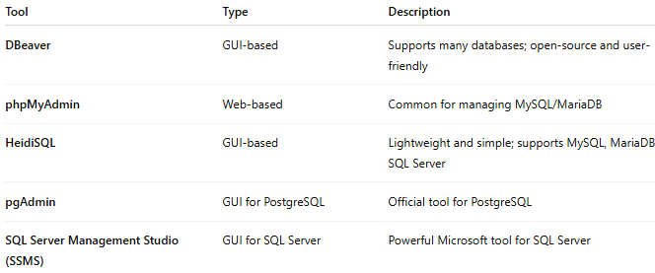
Tool | Type | Description
DBeaver | GUI-based | Supports many databases; open-source and user-friendly
phpMyAdmin | Web-based | Common for managing MySQL/MariaDB
HeidiSQL | GUI-based | Lightweight and simple; supports MySQL, MariaDB, SQL Server
pgAdmin | GUI for PostgreSQL | Official tool for PostgreSQL
SQL Server Management Studio (SSMS) | GUI for SQL Server | Powerful Microsoft tool for SQL Server

📦 Behind the Scenes
# Source: AI Source: Provided by: [Data Path: Persons Table -> ID Column: 1, Name_En Column: Motasem Essam] -> From: [ChatGPT] on [6/10/2026]
Databases store structured data (like customer info, orders, or products). A database management tool gives you a convenient way to work with that data, instead of typing everything manually in a terminal.

Difference between Database Management Tool and Database Management System
# Source: AI Source: Provided by: [Data Path: Persons Table -> ID Column: 1, Name_En Column: Motasem Essam] -> From: [ChatGPT] on [6/10/2026]
Great question! The terms Database Management Tool and Database Management System (DBMS) are related but very different in purpose and function.

⚙️ 1. Database Management System (DBMS)
# Source: AI Source: Provided by: [Data Path: Persons Table -> ID Column: 1, Name_En Column: Motasem Essam] -> From: [ChatGPT] on [6/10/2026]
A DBMS is the core software that actually stores, retrieves, and manages data in a database.
🔑 Key Points:
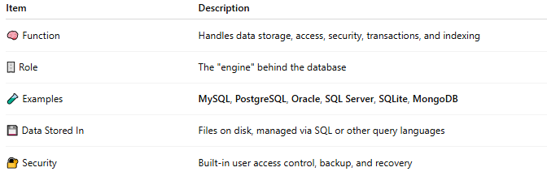
Item | Description
🧠 Function | Handles data storage, access, security, transactions, and indexing
🗄️ Role | The "engine" behind the database
🧪 Examples | MySQL, PostgreSQL, Oracle, SQL Server, SQLite, MongoDB
💾 Data Stored In | Files on disk, managed via SQL or other query languages
🔐 Security | Built-in user access control, backup, and recovery

🛠️ 2. Database Management Tool
# Source: AI Source: Provided by: [Data Path: Persons Table -> ID Column: 1, Name_En Column: Motasem Essam] -> From: [ChatGPT] on [6/10/2026]
A Database Management Tool is a software interface (GUI or CLI) used to interact with a DBMS more easily.
🔑 Key Points:
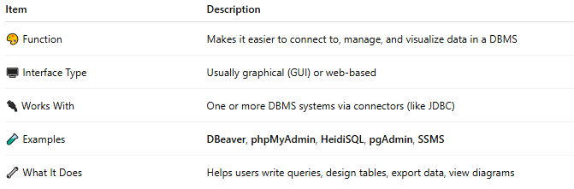
Item | Description
🎨 Function | Makes it easier to connect to, manage, and visualize data in a DBMS
🖥️ Interface Type | Usually graphical (GUI) or web-based
🔌 Works With | One or more DBMS systems via connectors (like JDBC)
🧪 Examples | DBeaver, phpMyAdmin, HeidiSQL, pgAdmin, SSMS
🔧 What It Does | Helps users write queries, design tables, export data, view diagrams

🔄 Summary Table
# Source: AI Source: Provided by: [Data Path: Persons Table -> ID Column: 1, Name_En Column: Motasem Essam] -> From: [ChatGPT] on [6/10/2026]
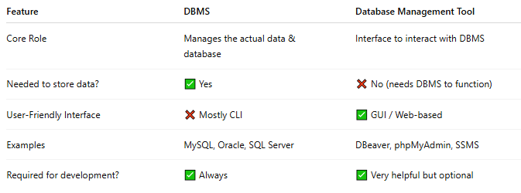
Feature | DBMS | Database Management Tool
Core Role | Manages the actual data & database | Interface to interact with DBMS
Needed to store data? | ✅ Yes | ❌ No (needs DBMS to function)
User-Friendly Interface | ❌ Mostly CLI | ✅ GUI / Web-based
Examples | MySQL, Oracle, SQL Server | DBeaver, phpMyAdmin, SSMS
Required for development? | ✅ Always | ✅ Very helpful but optional

🔁 Analogy:
# Source: AI Source: Provided by: [Data Path: Persons Table -> ID Column: 1, Name_En Column: Motasem Essam] -> From: [ChatGPT] on [6/10/2026]
DBMS = Car engine
Tool = Dashboard & steering wheel
You need the engine to drive (store/query data), but the dashboard makes it easier to control everything.

